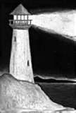

The Bethel Beacon

Bethel United Methodist Church January, 2012

C:\Users\Matt Schaeffer\AppData\Local\Microsoft\Windows\Temporary Internet Files\Content.IE5\P3EIHFWB\MC900432365[1].wmf

Happy

New

Year!

I hope that all of you had a very joyous Christmas, wherever the holiday took you. As much as I love white Christmases, it was a pleasure *not* to be shoveling the driveway this past week. You may remember last year’s day-after-Christmas blizzard and the difficulties it caused. May the good weather continue.

Christmas at Bethel was an extended experience this year. It began with all the special charity drives that come around during Advent – *Samaritan’s Purse, The Methodist Children’s Home, the South Shore Food Pantry, & Project Hospitality.* Vicky Rivelli, Dawn Lagno, and Arlene Schweikert, decked our halls and sanctuary with wreathes and other ornaments. Many of you generously supported the church by purchasing poinsettias, which beautified the sanctuary. We showed *It’s a Wonderful Life* on December 3rd for Family Movie Night, we had Christmas Caroling on December 16th, and our Christmas Pageant was held on December 18th – Jack, Angelina, Eva, and Julianna put on quite a show! The Christmas party followed the service – I was happy that so many were able to join us. Several of the good ladies of Bethel assembled seventeen Love Baskets, thanks in large part to the generosity of so many of you! We held our traditional Festival of Lessons and Carols on Christmas Eve, graced by Anthony DiBlasio on drums, Alex Henoumont on guitar, and Kathy Powell (I call her “Mom”) on piano. Finally, Christmas morning (on a Sunday!) we enjoyed more carols and songs, including an anthem sung by our Christmas Choir.

As I consider the pace of activity at Bethel over the past few months, I am pleased to say that every season is a bit of a Christmas season at church. The joy of Christmas remains with us year round, as does the giving, and the music, and Sunday School, and fellowship, and the excitement of being in worship and service together as disciples of Jesus Christ. The Savior who we come to meet in Bethlehem on Christmas morning stays with us every minute of our lives. He counsels, comforts, and empowers us not to remain at the manger but to bring good tidings to all the world, to share the joy of Christmas with those who so need to hear the good news of God’s unconquerable love and grace. May God bless each of you with a perpetual spirit of Christmas, that you may live it utter amazement of God’s wondrous gift in Jesus Christ.

Yours faithfully in Christ,

In this edition:

Pastor’s welcome………………………..page 1

On the Radar (calendar)…………………page 2

Worship News…………………..……pages 3-4

Our Covenant……………………………page 5

Church Business………………………...page 6

Puzzle………………………………..…..page 6

December Gallery……………………….page 7

What’s on the Radar?





|  |  |  |  |  |  |  |
| --- | --- | --- | --- | --- | --- | --- |
| January 2012 | | | | | | |
| Sunday | Monday | Tuesday | Wednesday | Thursday | Friday | Saturday |
| 1  C:\Users\Matt Schaeffer\AppData\Local\Microsoft\Windows\Temporary Internet Files\Content.IE5\BVU5YDY9\MC900445546[1].wmf  Worship Service  11 A.M. | 2 | 3  BIBLE STUDY  7:00 P.M.  PARSONAGE  (241 BETHEL AVE)  C:\Users\Matt Schaeffer\AppData\Local\Microsoft\Windows\Temporary Internet Files\Content.IE5\GIXLG4IF\MC900383922[1].wmf | 4 | 5  CALL TO ACTION  MEETING  7:00 P.M.  CHURCH  C:\Users\Matt Schaeffer\AppData\Local\Microsoft\Windows\Temporary Internet Files\Content.IE5\BVU5YDY9\MC900283365[1].wmf | 6    EPIPHANY  C:\Users\Matt Schaeffer\AppData\Local\Microsoft\Windows\Temporary Internet Files\Content.IE5\P3EIHFWB\MC900415368[1].wmf | 7 OLD TIME  GOSPEL WORSHIP  5:30 P.M.  C:\Users\Matt Schaeffer\AppData\Local\Microsoft\Windows\Temporary Internet Files\Content.IE5\6VWMULJ9\MC900434773[1].png  FAMILY MOVIE NIGHT 7 P.M.  C:\Users\Matt Schaeffer\AppData\Local\Microsoft\Windows\Temporary Internet Files\Content.IE5\BVU5YDY9\MC900250766[1].wmf |
| 8 BAPTISM  OF THE LORD  C:\Users\Matt Schaeffer\AppData\Local\Microsoft\Windows\Temporary Internet Files\Content.IE5\GIXLG4IF\MC900058397[1].wmf  Worship Service  11 A.M. | 9  Spanish Class  7:45 p.m.  CHURCH  C:\Users\Matt Schaeffer\AppData\Local\Microsoft\Windows\Temporary Internet Files\Content.IE5\6VWMULJ9\MC900056589[1].wmf | 10  BIBLE STUDY  7:00 P.M.  PARSONAGE  (241 BETHEL AVE)  C:\Users\Matt Schaeffer\AppData\Local\Microsoft\Windows\Temporary Internet Files\Content.IE5\GIXLG4IF\MC900383922[1].wmf | 11 CHURCH  COUNCIL  7:30 P.M.  CHURCH  C:\Users\Matt Schaeffer\AppData\Local\Microsoft\Windows\Temporary Internet Files\Content.IE5\6VWMULJ9\MC900230770[1].wmf | 12 | 13 | 14    OLD TIME  GOSPEL WORSHIP  5:30 P.M.  C:\Users\Matt Schaeffer\AppData\Local\Microsoft\Windows\Temporary Internet Files\Content.IE5\6VWMULJ9\MC900434773[1].png |
| 15  HUMAN RELATIONS  DAY  C:\Users\Matt Schaeffer\AppData\Local\Microsoft\Windows\Temporary Internet Files\Content.IE5\P3EIHFWB\MC900089907[1].wmf  Worship Service  11 A.M. | 16MARTIN  LUTHER  KING’S  BIRTHDAY  **C:\Users\Matt Schaeffer\AppData\Local\Microsoft\Windows\Temporary Internet Files\Content.IE5\GIXLG4IF\MC900370454[1].wmf**  Spanish Class  7:45 p.m.  CHURCH | 17  PASTOR  OUT-OF-TOWN  (Bishop’s Convocation) | 18 Staten Island  Prayer Service  (Zion Lutheran)  7 p.m.  C:\Users\Matt Schaeffer\AppData\Local\Microsoft\Windows\Temporary Internet Files\Content.IE5\GIXLG4IF\MC900057282[1].wmf  PASTOR  OUT-OF-TOWN  (Bishop’sConvocation) | 19  PASTOR  OUT-OF-TOWN  (Bishop’s Convocation) | 20  TRUSTEES  MEETING  10 A.M.  CHURCH  C:\Users\Matt Schaeffer\AppData\Local\Microsoft\Windows\Temporary Internet Files\Content.IE5\6VWMULJ9\MC900230770[1].wmf | 21  YOUNG  ADULT  NIGHT OUT  5:30 – 8 P.M.  C:\Users\Matt Schaeffer\AppData\Local\Microsoft\Windows\Temporary Internet Files\Content.IE5\BVU5YDY9\MC900440434[1].wmf |
| 22  ECUMENICAL  SUNDAY  C:\Users\Matt Schaeffer\AppData\Local\Microsoft\Windows\Temporary Internet Files\Content.IE5\GIXLG4IF\MC900439613[1].png  Worship Service  11 A.M. | 23  Spanish Class  7:45 p.m.  CHURCH  C:\Users\Matt Schaeffer\AppData\Local\Microsoft\Windows\Temporary Internet Files\Content.IE5\6VWMULJ9\MC900056589[1].wmf | 24  BIBLE STUDY  7:00 P.M.  PARSONAGE  (241 BETHEL AVE)  C:\Users\Matt Schaeffer\AppData\Local\Microsoft\Windows\Temporary Internet Files\Content.IE5\GIXLG4IF\MC900383922[1].wmf | 25  SOUTH SHORE  COUNCIL  MEETING  11:00 A.M.  CHURCH  C:\Users\Matt Schaeffer\AppData\Local\Microsoft\Windows\Temporary Internet Files\Content.IE5\BVU5YDY9\MC900283365[1].wmf | 26  C:\Users\Matt Schaeffer\AppData\Local\Microsoft\Windows\Temporary Internet Files\Content.IE5\BVU5YDY9\MC900439857[1].wmf  Leadership  Training  Meeting  7 p.m.  (87 Nashville St.) | 27  Submission deadline for February newsletter  C:\Users\Matt Schaeffer\AppData\Local\Microsoft\Windows\Temporary Internet Files\Content.IE5\BVU5YDY9\MC900389482[1].wmf | 28 DISTRICT  LEADERSHIP  TRAINING  (St. Paul’s)  9:30 a.m.–3 p.m.  C:\Users\Matt Schaeffer\AppData\Local\Microsoft\Windows\Temporary Internet Files\Content.IE5\BVU5YDY9\MM900283479[1].gif  OLD TIME  GOSPEL WORSHIP  5:30 P.M.  C:\Users\Matt Schaeffer\AppData\Local\Microsoft\Windows\Temporary Internet Files\Content.IE5\6VWMULJ9\MC900434773[1].png |
| 29 Spring Fair  Planning Meeting  (after church)  C:\Users\Matt Schaeffer\AppData\Local\Microsoft\Windows\Temporary Internet Files\Content.IE5\6VWMULJ9\MC900439859[1].wmf  Worship Service  11 A.M. | 30 31  Pastor’s vacation | | | | | |

Worship News

**C:\Users\Matt Schaeffer\AppData\Local\Microsoft\Windows\Temporary Internet Files\Content.IE5\P3EIHFWB\MC900056148[1].wmf**

**Human Relations Day: January 15th**

Human Relations Day is about community. Too often, people feel disenfranchised and neglected in our society. Our Human Relations Day offering supports vital ministries that teach and advocate justice, community development, self-improvement, and rehabilitation. Our gifts promote ministries for the most vulnerable, the most marginalized people in our nation, ministries that provide people with their basic survival needs and advocate for the most vulnerable people in society. Please give generously to this ministry! You may find more information at the following link:

<http://www.umcgiving.org/site/c.qwL6KkNWLrH/b.6817081/k.83AD/Human_Relations_Day_Sunday.htm>

C:\Users\Matt Schaeffer\AppData\Local\Microsoft\Windows\Temporary Internet Files\Content.IE5\6VWMULJ9\MC900415368[1].wmf

So…what *is* Epiphany?

The word *epiphany* is derived from the Greek word ἐπιφάνεια (*epiphaneia)*, which means ‘appearance’ or ‘manifestation.’ Epiphany was originally a celebration of both the magi’s visit to Jesus (read “We Three Kings”) *and* Jesus’ baptism. In the Roman Catholic and Western Protestant Churches (which follow the Gregorian calendar), the celebration is held on January 6th while the Eastern Orthodox Church (which follows the Julian calendar) celebrate it on January 19th. While in the Eastern Church Epiphany commemorates Jesus’ baptism, in the Western Church the emphasis is on the visit of the magi, or God’s revelation to the Gentiles – the West celebrates Baptism of the Lord on January 8th this year).

The magi from the East (likely Iraq or Iran, descendents of the Babylonians or Persians) are astrologers (possibly of the Zoroastrian religion) and know that a great king is born, but Herod the Great, king of Judea is oblivious of this event. While the magi come to give homage to baby Jesus, King Herod attempts to kill the Christ child.

Over the centuries, the story of Epiphany has been embellished. Though the gospel of Matthew does not say how many magi came to Bethlehem, tradition has assumed there were three (since three gifts – gold, myrrh, and frankincense - were presented to Jesus). By the sixth century the three magi were given names: Melchior (a Babylonian scholar), Caspar (a Persian scholar), and Balthazar (an Arab scholar). By the eighth century, the wise men had evolved into kings of the same names. Early Chinese Christians have claimed that one of the magi came from China, and there is an Armenian tradition that identifies one of the magi’s origins as India.

Week of Prayer for Christian Unity:

January 18-25

The theme for the 2012 Week of Prayer for Christian Unity is*: We will all be changed by the victory of Our Lord Jesus Christ* (cf. I Corinthians 15:51–58) *.*   
Representatives of the Roman Catholic Church, the Orthodox Church and Old Catholic and Protestant Churches in Poland decided to focus on a theme that is concerned with the transformative power of faith in Christ, particularly in relation to our praying for the visible unity of the Church, the Body of Christ. It is based on St Paul's words to the Corinthian Church which speak of the temporary nature of our present lives in comparison to what we receive through the victory of Christ. This "victory" is only possible through spiritual transformation. As we pray for and strive towards the full visible unity of the church we, and the traditions to which we belong, will be changed, transformed and conformed to the likeness of Christ.  It is in His life, action, teaching, suffering, death and resurrection that we seek inspiration for a modern victorious life of faith. As he awaited the suffering and death that was to come, he prayed that his disciples might be one so that world might believe. Please join together with Christians around the world as we pray for and strive towards the full visible unity of the Church as it will be changed, transformed and conformed to the likeness of Christ. On Staten Island, this Week of Prayer commences with an ecumenical worship service at Zion Lutheran Church, 505 Watchogue Road, at 7 p.m. on January 18th.

More Worship News

HELP WANTED

Opportunities are available for a variety of tasks at Bethel. The only qualification needed is a desire to serve God by serving the Church. We currently need individuals to serve as:

* Communion stewards
* Musicians/singers
* Liturgists
* Cooks (prepare meals)
* Acolytes
* Worship planners
* Sanctuary straighten-uppers
* Babysitters
* Teachers’ helpers
* Newsletter preparers
* Coffee Hour Helpers

If you would like to help in these ways, or in any other way, please speak to the pastor (718-984-1277)

READINGS FOR JANUARY

|  |  |  |  |  |
| --- | --- | --- | --- | --- |
| Epiphany Year B | First reading | Psalm | Second reading | Gospel |
| [**Epiphany of the Lord**](http://lectionary.library.vanderbilt.edu/texts.php?id=59) January 6, 2012 | [Isaiah 60:1-6](http://lectionary.library.vanderbilt.edu/texts.php?id=59) | [Psalm 72:1-7, 10-14](http://lectionary.library.vanderbilt.edu/texts.php?id=59) | [Ephesians 3:1-12](http://lectionary.library.vanderbilt.edu/texts.php?id=59) | [Matthew 2:1-12](http://lectionary.library.vanderbilt.edu/texts.php?id=59) |
| [**Baptism of the Lord**](http://lectionary.library.vanderbilt.edu/texts.php?id=60) January 8, 2012 First Sunday after the Epiphany | [Genesis 1:1-5](http://lectionary.library.vanderbilt.edu/texts.php?id=60) | [Psalm 29](http://lectionary.library.vanderbilt.edu/texts.php?id=60) | [Acts 19:1-7](http://lectionary.library.vanderbilt.edu/texts.php?id=60) | [Mark 1:4-11](http://lectionary.library.vanderbilt.edu/texts.php?id=60) |
| [**Second Sunday after the Epiphany**](http://lectionary.library.vanderbilt.edu/texts.php?id=61) January 15, 2012 | [1 Samuel 3:1-10, (11-20)](http://lectionary.library.vanderbilt.edu/texts.php?id=61) | [Psalm 139:1-6, 13-18](http://lectionary.library.vanderbilt.edu/texts.php?id=61) | [1 Corinthians 6:12-20](http://lectionary.library.vanderbilt.edu/texts.php?id=61) | [John 1:43-51](http://lectionary.library.vanderbilt.edu/texts.php?id=61) |
| [**Third Sunday after the Epiphany**](http://lectionary.library.vanderbilt.edu/texts.php?id=62) January 22, 2012 | [Jonah 3:1-5, 10](http://lectionary.library.vanderbilt.edu/texts.php?id=62) | [Psalm 62:5-12](http://lectionary.library.vanderbilt.edu/texts.php?id=62) | [1 Corinthians 7:29-31](http://lectionary.library.vanderbilt.edu/texts.php?id=62) | [Mark 1:14-20](http://lectionary.library.vanderbilt.edu/texts.php?id=62) |
| [**Fourth Sunday after the Epiphany**](http://lectionary.library.vanderbilt.edu/texts.php?id=63) January 29, 2012 | [Deuteronomy 18:15-20](http://lectionary.library.vanderbilt.edu/texts.php?id=63) | [Psalm 111](http://lectionary.library.vanderbilt.edu/texts.php?id=63) | [1 Corinthians 8:1-13](http://lectionary.library.vanderbilt.edu/texts.php?id=63) | [Mark 1:21-28](http://lectionary.library.vanderbilt.edu/texts.php?id=63) |

**Our Covenant:**

BIRTHDAYS IN JANUARY

The 4th …………Jessica Belnavis

The 10th………….Alyssa Tatarka

and…………...…..Annika Harkin

The 15th ……….Tom Kasprowitz

The 16th …………Donna Bergrin

The 30th …………Matt Schaeffer

If you have a birthday in January and you’d like to be on the list, please contact the pastor at (718) 984-1277.

**LITURGISTS FOR JANUARY**

January 8th …….……Al Gundersheimer

January 15th ………………Carol Plumb

January 22nd ………………Greg Adams

January 29th ………..Diane Kasprowitz

**Contemporary Worship on Saturday Nights.**

**Bethel holds a worship service on Saturdays at 5:30 p.m. We invite you to join us on Saturdays at 5:30 pm for worship featuring contemporary Christian praise songs, preaching, prayer, and fellowship.**

**MC900094703[1] MC900237382[1]**

New Officers for 2012

We would like to recognize and congratulate officers and servants for 2012:

**ADMINISTRATIVE COUNCIL**

Council Chair…………………………………………..……..Ed Josey

Lay Leader……………………...…………………...Arlene Schweikert

Lay Members to NYAC………Jason Ciarlante and Nick Henoumont

Finance Chair…………………………………………….Karen Jensen

Treasurer…………………………………………………...Vicky Rivelli

Financial Secretary………………………………………..Gloria Shaw

S/PPRC Chair…………………………………….....Diane Kasprowitz

Trustees Chair…………………………………...……Tom Kasprowitz

Memorial Chair…………………………………………………EC Toth

Membership Secretary…………………………………... Dottie Baker

Education Team Representative……………………….Beth Cherrick

Records & History Chair………………………………….Carol Plumb

Members at-large……………….Lillian Leary and Al Gundersheimer

Coordinator of Young Adult Ministries…………………….Ken Quick

Cranberry Festival Chair…………………………...Diane Kasprowitz

Committee on Nominations and Leadership Development  
 **Class of 2012            Class of 2013                  Class of 2014** Diane Kasprowitz            Carol Josey                     Lillian Leary  
 Shirley Blauth               Dottie Baker                   Karen Jensen

                                                                                          Laura Ryan

Committee on Staff/Pastor-Parish Relations  
 **Class of 2012            Class of 2013                  Class of 2014**  
 Gloria Shaw              Mary Worstell                     Vicky Rivelli  
 Elaine Rogers           Diane Kasprowitz                Greg Adams  
 Al Gundershiemer            Ed Josey

Board of Trustees

**Class of 2012            Class of 2013                  Class of 2014** Don Bischoff              Karen Jensen                       Ed Josey    
 Lillian Leary            Tom Kasprowitz                 George Jensen  
 Vicky Rivelli                                                          EC Toth

Stewardship Coordinators……..Carol Josey and Jason Ciarlante

PLEASE PRAY FOR OUR LEADERS!

To faithfully share our prayers, our presence, our gifts, our service, our witness

to the glory of our Lord and Savior Jesus Christ

**Our Prayers**

“Rejoice in hope, be patient in suffering, persevere in prayer.” (Romans 12:12)

Please pray for the family of Peter Figoski, the family of David Hawke, Glen Hall, the Albright family, Marcella, Gordon and Mildred Ekstrand, Alissa Refano, Cindy Lubniewski, Luis Gonzalez, Ju Hae, Chris Kristaflakis, Wally Eagle, Mary Dyer, Gladys Dahlquist, Joyce and Janet, Jim Secola, Danny, Tracy, Barbara Curcio, the Sterner family, Donna Bergrin, Rudy Geiger, Leslie Alleyne, Hector Ortiz, Seth, John Schaeffer, Patti Sportiello, the family of Evelyn Salerno, Diane Gerardi, James Cambareri, Paul Lol Norden, Valerie Espinoza, Naz Sael, Jerry, Lucas, Tracy, Hilj VanPelt, the family of Mary and James Regan, Cathy Kasza, the family of Woody Smith, Danielle S., Nicole Jensen, Carole Passarini, Shirley Blauth, the Shiekes family, Frankie Filapazzo and family, Anula, Donald, Triveni, and Dinu Perera, Alex Yates, Richard, Jimmy Hills, Dorothy Dolan, Don & Carol Josey, Celia Perla, Mary Lake, Adrian, Elise Weiser, Peter Rocchio, Robert Helbig, Nancy Aaman, Pearl Ameduri, John Gelles, Bill Cameron, Caroline Hockins, Marion Iatauro, Irene Olsen, Carol Plumb, Ann Reimenschneider, Isabel and Victor Taylor, Samila, Al Gundersheimer, Joan, Carol, Cara, the people of Haiti, the people of North and South Korea, the people who are struggling for human rights across the world, those who are seeking employment, our service members, veterans, and their families, and for the faithful ministry of Bethel UMC.

**Our Presence**

“You are the light of the world. A city built on a hill cannot be hidden.” (Matthew 5:14)

As light-bearing Christians, we bring Christ’s presence to others. As people identify you as a Christian, you may unwittingly become a source of peace and comfort to them. Let your light shine in all circumstances, among all people, that they may be drawn to the source of that light!

**Our Gifts**

“…let them offer thanksgiving sacrifices, and tell of his deeds with songs of joy.” (Psalm 107:22)

Christians recognize that, whether they live across the street or across the world, everyone is our neighbor. And if a neighbor needs help, we are obliged to do whatever we can to help. All you have to do is read the news to recognize the enormous need of our neighbors near and far. John Wesley, in his sermon *Serving God with Mammon,* instructs us to “…gain all you can, save all you can, then give all you can.” In other words, the purpose of our hard work and our saving is that we can give more. And considering that all you have, including life itself, belongs to God, what can you afford not to give?

**Our Service**

“Truly I tell you, just as you did it to the least of these my brothers or sisters, you did it to me.” (Matthew 25:40)

There is no greater privilege or joy in the world than to be a servant of the Living God. Jesus reminds us that we encounter him when we serve “the least of these my brothers and sisters.” As Christians we must step further out of our “comfort zones,” in order to become better servants of Jesus Christ.

**Our Witness**

“And the Word became flesh and lived among us, and we have seen his glory, the glory as of a father’s only son, full of grace and truth.” (John 1:14)

Consider how your life has been changed since you met Jesus Christ. Consider how God has blessed you. Now think about those who don’t know God’s goodness and grace. There is no greater news that one can hear than an all-loving God dwells with us and desires nothing more than to save us, to bring healing to our hearts and to this world. No need to be a closet Christian; the Gospel is too good to keep to ourselves. Boldly share Jesus with a world that is hungry for some Good News!

Church Business

Bethel to Get a Facelift

It’s official: we are moving forward with plans to re-face the front of the church. According to experts in brickfacing, the stucco that was put on our church in the 1970s was designed to last around 20 years. Well, it’s been over 30 years, and the trustees prayerfully considered what we should do to fix the problems that were becoming apparent. We didn’t want to keep applying bandages, and we wanted a solution that would be affordable, durable, and ensure the safety of our congregation as well as those in other organizations that use our church. After months of research and securing various bids and proposals, we contracted with Garden State Brickface to begin a complete refacing of the front of the church. **All members are encouraged to attend a meeting on January 11th at 7:30 p.m. at Bethel.** A representative from Garden State Brickface will be available to answer any questions regarding the work to be done. We would also appreciate your input on the upcoming work…like choosing the color and style of the brickface. Looking forward to seeing you there!

Tuesdays 7-8 p.m.

Only $7 per lesson!

First lesson is free

for teens and youth!

Have Fun with Mark!

The lectionary readings for January 8th, 22nd, and 29th come from the first chapter of Mark. Read the entire chapter, then test your knowledge with this puzzle. Good luck!

**Across**

1. What Jesus did to the unclean spirit.

5. People were going to see John to be ________.

7. The man whose mother-in-law Jesus healed.

8. The occupation of Jesus' first disciples.

**Down**

2. Jesus didn't permit these to speak, because they knew him.

3. Because the leper proclaimed him freely, Jesus could no longer go into the cities and instead had to stay here.

4. The one who tempted Jesus in the wilderness.

6. The prophet who originally wrote, "Prepare the way of the Lord, and make his paths straight."



Support Saint Paul’s Food Pantry

In these difficult times of high unemployment and cuts in government spending, more and more people are finding it harder and harder to make ends meet and relying upon the Church to help **them get by. Bethel Church collects** **non-perishable food items for Saint** Paul’s Food Pantry. Our collection basket is just inside the front door of the church. As the Thanksgiving and Christmas Holidays approach, let us remember what God has blessed us with and make a concerted effort to share it with others. The next time you go grocery shopping, pick up something for those in need knowing that you bring them not only food but assurance of God’s providence!

C:\Users\Matt\AppData\Local\Microsoft\Windows\Temporary Internet Files\Content.IE5\YT70PALE\MC900300073[1].wmf

C:\Users\Matt\AppData\Local\Microsoft\Windows\Temporary Internet Files\Content.IE5\YT70PALE\MC900300073[1].wmf

C:\Users\Matt\AppData\Local\Microsoft\Windows\Temporary Internet Files\Content.IE5\YT70PALE\MC900300073[1].wmf

C:\Users\Matt\AppData\Local\Microsoft\Windows\Temporary Internet Files\Content.IE5\YT70PALE\MC900300073[1].wmf

C:\Users\Matt\AppData\Local\Microsoft\Windows\Temporary Internet Files\Content.IE5\YT70PALE\MC900300073[1].wmf

C:\Users\Matt\AppData\Local\Microsoft\Windows\Temporary Internet Files\Content.IE5\YT70PALE\MC900300073[1].wmf

## Judo & Aikido

For Youth, Teens, & Adults

with

Blackbelt Instructors:

## Claire and Dave Dogery

## Judo

## For more info, call

## Claire at (718) 984-3488 or Bethel Church at (718) 984-1277

December Gallery

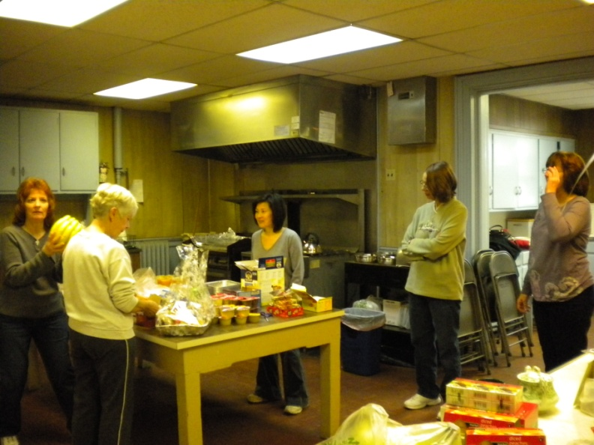 The Love Brigade making Love Baskets

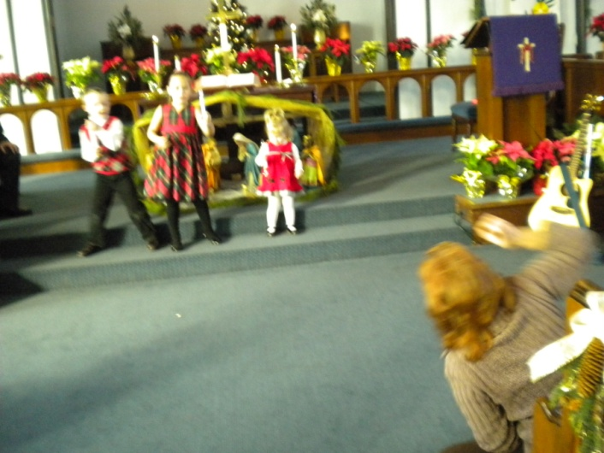

Prompts? We don't need no prompts!

A well-deserved Christmas treat!

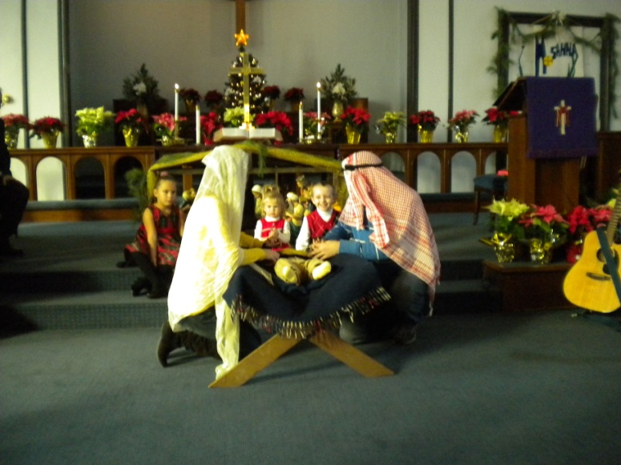

Who is that holy couple?

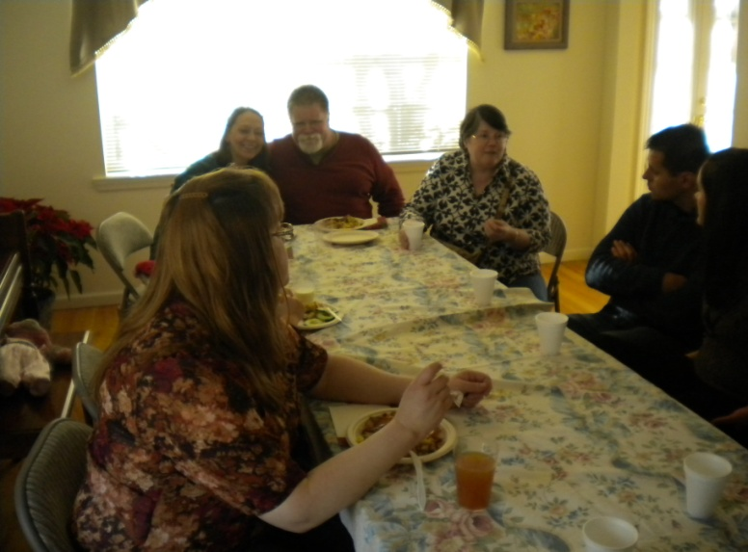 Lunch break at the parsonage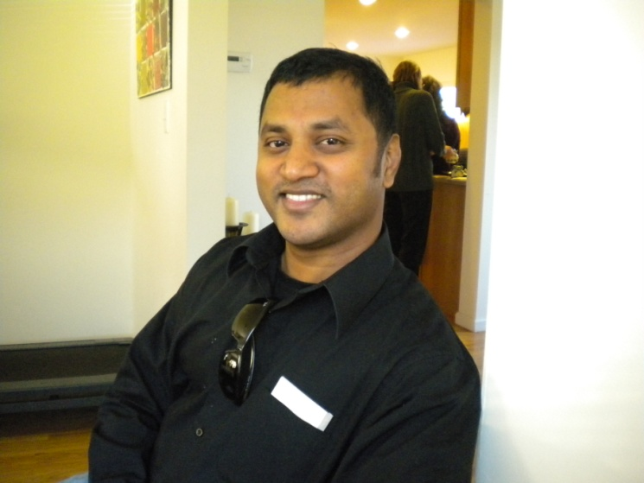The food really was that good!

Bethel United Methodist Church

7033 Amboy Road

Tottenville, Staten Island, NY 10307

#### Pastor Matt Schaeffer

**Bethel United Methodist Church**

**7033 Amboy Road**

**Tottenville, NY 10307**

**Office: (718) 984-1277**

**Parsonage: (718) 984-1354**

**bumcsi@verizon.net**

**Sunday Schedule**

11:00 A.M.: Worship

11:15 A.M.: Sunday School (after Children’s Sermon)

12:15 pm Social Hour

**Saturday Worship: 5:30 P.M.**

**Tuesday Bible Study: 7:00 P.M.** (at the parsonage)

**Prayer Service: 6:00 – 7:00 A.M. daily**

**Family Movie Night: the first Saturday of every month, 7:00 p.m.**

**Church office hours: Tuesday – Thursday, 9 a.m. – 3 p.m.**

**Fridays and Saturdays by appointment**